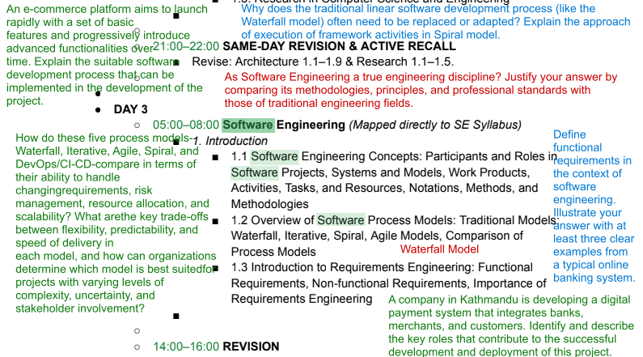

Extracted Questions
- How do these five process models—Waterfall, Iterative, Agile, Spiral, and DevOps/CI-CD—compare in terms of their ability to handle changing requirements, risk management, resource allocation, and scalability? What are the key trade-offs between flexibility, predictability, and speed of delivery in each model, and how can an organization determine which model is best suited for projects with varying levels of complexity, uncertainty, and stakeholder involvement?
- Why does the traditional linear software development process (like the Waterfall model) often need to be replaced or adapted? Explain the approach of execution of framework activities in the Spiral model.
- As Software Engineering is a true engineering discipline? Justify your answer by comparing its methodologies, principles, and professional standards with those of traditional engineering fields.
- Define functional requirements in the context of software engineering.
- Define functional requirements in the context of software development. Explain your answer with at least three clear exampies from a typical online examination system.
- Illustrate your answer with at least three clear examples from a typical online banking system.
- A company in Kathmandu is developing a digital payment system that integrates banks, merchants, and customers. Identify and describe the key roles that contribute to the successful development and deployment of this project.
- An e-commerce platform aims to launch rapidly with a set of basic features and progressively introduce advanced functionalities over time. Explain the suitable software development approach that can be implemented in the development of the project.
- What is a non-functional requirement? List out and explain the various non-functional requirement of the software system.

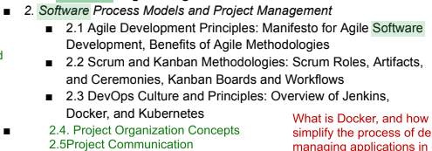

Software Engineering Questions Extracted
- Discuss the use and importance of Subversion, Jenkins, Docker and Kubernetes in detail.
- CI/CD
- Why do we need a DevOps-driven approach for the software development process? Explain the automated tools that contribute to the smooth deployment and operation of software systems.
- Agile process model is replacing traditional models in software development. Illustrate with example, what makes agile suitable compared to the traditional ones.
- Explain the core values and principles of the Agile Manifesto. How do they influence software development practices?
- The Scrum process is widely adopted in modern Agile software development. Explain the various artifacts and ceremonies used in a Scrum-based software development.
- What is Docker, and how does it simplify the process of deploying and managing applications in different environments?
- A software company is facing frequent delays in product releases due to slow manual testing and poor collaboration between development and QA teams. The company plans to implement DevOps practices with a focus on test automation, Continuous Integration (CI) using Jenkins, and containerization with Docker. Explain how these DevOps practices can help resolve the issues. What steps should the company take to implement them?
- Analyze the interplay between project organization (including roles, task assignment, and scheduling) and project communication (such as planned vs. unplanned communication, tools, and meetings) in software project management. How do these elements collectively contribute to the success or failure of a project, and what strategies can be employed to ensure they work jointly to achieve project goals? Provide example to support your analysis.
- What are the various phases of requirement Engineering? How requirement elicitation is crucial in requirement engineering?
- A software company is facing frequent delays in product releases due to siow manual testing and poor collaboration between the development and QA teams. The company plans to implement DevOps practices with a focus on test automation, Continuous Integration (CI) using Jenkins, and containerization with Docker.Explam how these DevOps practices can help resolve the issues.what steps should the company take to implement them effectively?
- Describe the different QA activities and their significance.Differentiate Faults, Erroneous States and Failures with example.

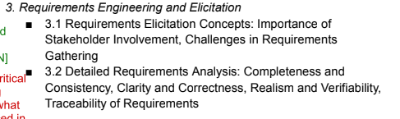

- A software development team is tasked with building an online food delivery platform that allows customers to order food from local restaurants, track their orders in real-time, and make payments online. The platform should also support restaurant owners in managing menus, orders, and delivery schedules, while providing delivery personnel with tools to accept and complete delivery requests.
  - Who are the key actors and stakeholders involved in this system? Provide a list and briefly describe their roles and interests.
  - Create two scenarios, one for a customer placing an order and another for a restaurant owner updating their menu. Based on these scenarios, draft initial use cases for each scenario.
  - Draw a use case diagram that illustrates the relationships between the actors (e.g., customer, restaurant owner, delivery personnel) and the use cases (e.g., place order, update menu, track delivery). Explain how these relationships ensure the system meets the needs of all stakeholders.
- A software development team is tasked with building an online food delivery system. Develop use cases for each scenario for all stakeholders.
- Why is stakeholder involvement critical during the requirements gathering phase of a software project, and what are some common challenges faced in ensuring effective participation from all stakeholders? How can these challenges be addressed to ensure accurate and comprehensive requirements?(5)
- Why is stakeholder involvement crucial in requirements elicitation? Explain the challenges faced during the requirements gathering process and how they can impact the success of a software project.

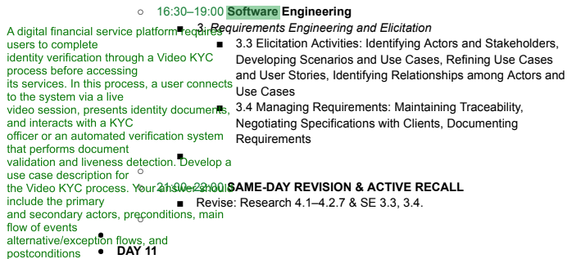

Question 1 — Use Case Description
A digital financial service platform requires users to complete identity verification through a Video KYC process before accessing its services. In this process, a user connects to the system via a live video session, presents identity documents, and interacts with a KYC officer or an automated verification system that performs document validation and liveness detection. Develop a use case description for the Video KYC process.
Your answer should include:
- Primary actor
- Secondary actors
- Preconditions
- Main flow of events
- Alternative/exception flows
- Postconditions

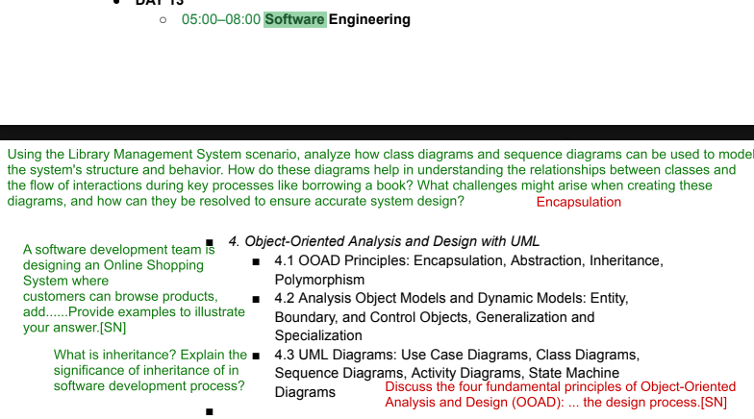
- Using the Library Management System scenario, analyze how class diagrams and sequence diagrams can be used to model the system's structure and behavior. How do these diagrams help in understanding the relationships between classes and the flow of interactions during key processes like borrowing a book? What challenges might arise when creating these diagrams, and how can they be resolved to ensure accurate system design?
- A software development team is designing an Online Shopping System where customers can browse products, add items to a cart, and place orders. The system also allows administrators to manage inventory and process orders.
  - Identify the key use cases (e.g., "Add to Cart," "Place Order") and map them to the objects involved (e.g., Customer, Product, Cart, Order).
  - Create a class diagram showing the relationships between objects, such as how a Customer associates with a Cart and how a Cart aggregates Product objects.
  - Identify any inheritance relationships, such as different types of users (e.g., Customer and Admin inheriting from a User class).
  - Explain how these modeling techniques help in understanding the behavior and structure of the Online Shopping System.
  - Provide examples to illustrate your answer.
- What is inheritance? Explain the significance of inheritance in the software development process?
- Explain the terms Encapsulation and Abstraction in the context of software engineering? How these features in OOP contribute in the development of complex real-world application?
- Discuss the four fundamental principles of Object-Oriented Analysis and Design (OOAD): Encapsulation, Abstraction, Inheritance, and Polymorphism. Explain how each principle contributes to effective software design, and support your explanation with relevant real-world examples.
- A bank wants to develop an online banking system that allows customers to check balances, transfer money, and pay bills. The system should also have an admin panel to manage customer accounts and transactions.
  - Draw a Use Case Diagram for this system and describe the key actors and their roles.
  - Also, explain how Entity, Boundary, and Control Objects can be used in the design process.
- A university is facing challenges in verifying the identity of students accessing its online academic services such as course registration, examination portals, and digital transcripts. To address this, the university plans to implement a multi-factor authentication (MFA)-based digital identity verification system (DIVS).
In this process, a student logs into the university portal using their credentials (registration number and password), followed by additional verification methods such as a One-Time Password (OTP) sent to their registered email. The system may also validate student records against the university database to ensure authenticity. This approach helps the university prevent unauthorized access, reduce impersonation during online examinations, and ensure secure access to sensitive academic information and services.
Develop a use case description for the Digital Identity Verification System (DVIS). Your answer should include the primary and secondary actors, preconditions, main flow of events, alternative/exception flows, and postconditions.

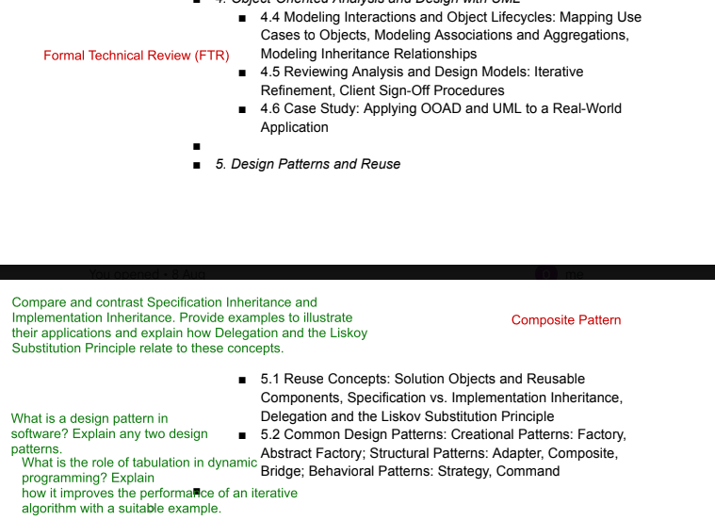
- Compare and contrast Specification Inheritance and Implementation Inheritance. Provide examples to illustrate their applications and explain how Delegation and the Liskov Substitution Principle relate to these concepts.
- What is a design pattern in software? Explain any two design patterns.
- FTR
- Composite pattern
- What is a design pattern? How design pattern supports in reusability? Explain the creational design pattern with an example.

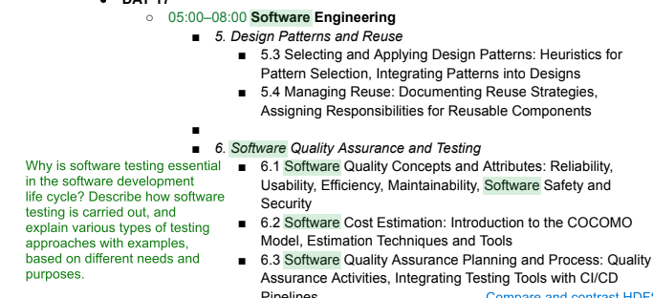
- Why is software testing essential in the software development life cycle? Describe how software testing is carried out, and explain various types of testing approaches with examples, based on different needs and purposes.
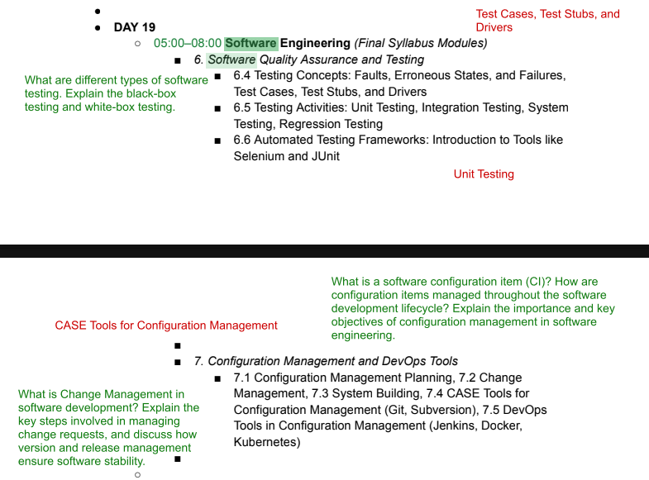
- What are different types of software testing? Explain the black-box testing and white-box testing.
- What is a software configuration item (CI)? How are configuration items managed throughout the software development lifecycle? Explain the importance and key objectives of configuration management in software engineering.
- What is Change Management in software development? Explain the key steps involved in managing change requests, and discuss how version and release management ensure software stability
- Unit Testing
- Test cases , Test stubs and Drivers
- Describe the Test Stub and Test driver. Why and how integration testing is carried out? Explain.
- CASE Tools for configuration management
- Explain the process of incorporating change in development process. How has CASE tools changed the process of version and release management in present context? Discuss in brief.

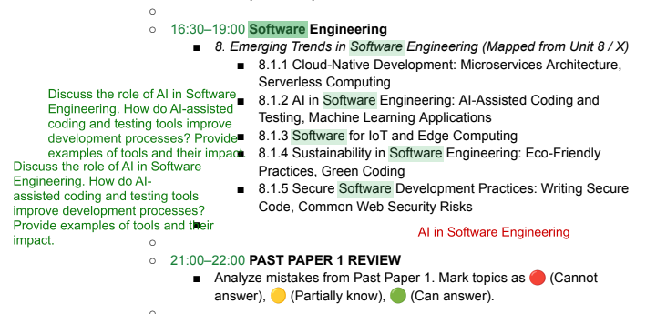
- Discuss the role of AI in Software Engineering. How do AI-assisted coding and testing tools improve development processes? Provide examples of tools and their impact.
- AI in Software Engineering.
- Cloud Native Development has largely impacted the development process. Discuss how?
- Sustainability and Environment Concerns are impacting the field of IT, How? What considerations do we need to make while deploying software solutions in current context? Discuss.
- Serverless Computing

